Herbert R. Hartel, Jr.

196-41 69th Avenue  
2nd floor  
Fresh Meadows, NY 11365

**O’KEEFFE,** **GEORGIA Word Count: 549**

Georgia O’Keeffe (1888-1887) was one of the most important American and women artists of the twentieth century and a leading pioneer of abstraction. She is most famous for her sensuously colored abstractions and enlarged-close-ups of flowers created in the late-1910s and 1920s, and her paintings of animal bones done in 1930s and 1940s. O’Keeffe was born near Sun Prairie, Wisconsin in 1887 and raised on farms there and in Williamsburg, Virginia. Her interest in art developed as a child, when she received lessons from a few local women artists. She was supposedly told by one teacher to make her still lifes bigger, an admonition that permanently effected her work. She studied at the Art Institute of Chicago, the Chase Art School, and Teachers’ College of Columbia University. She then taught art in colleges in South Carolina and Texas for several years. O’Keeffe’s early works on paper came to the attention of Alfred Stieglitz in 1916, who was very impressed with them and exhibited her work in his New York City gallery “291.” They became lovers by 1918 and married in 1924.

By 1919, O’Keeffe was working on a larger scale in oil on canvas. She did numerous pure abstractions which are striking for their rich harmonic colours and sensuous brushwork. These include *Blue and Green Music* (1919) and *Music: Pink and Blue I* and *II* (1920), which evoke synaesthetic emotive responses, the transformation of matter moving through space, and references to the female sexual anatomy. In the 1920s, she did hundreds of paintings of flowers and plants, usually as enlarged close-ups that emphasize details or abstract rhythms of growth and transformation. Among the best known are *Flower Abstraction,* *Red Canna*, *Black Iris III*, *Purple Petunia* and *Jack-in-the-Pulpit IV*. The critics responded harshly to these works and often dwelled on the sexual anatomy that many of them seemed to imply. Although O’Keeffe denied these works had sexual overtones, some unmistakably do, and these interpretations helped establish her reputation and sell her works. In the late-1920s and 1930s, O’Keeffe was influenced by Precisionism and Regionalism. *Radiator Building* (1927) uses an abstracted, Art Deco idiom to show her fascination with the skyscrapers that transformed American cities in the 1920s. In 1929, she made her first extended visit to New Mexico. She loved the Southwest and visited often. She depicted mountain and desert views, Penitente crosses and animal bones in careful detail or as enlarged abstractions. *Rancho de Taos Church*, *Cow’s Skull: Red, White and Blue* (both 1930) and *Pelvis–Red and Yellow* (1945) are important examples of her New Mexico paintings. O’Keeffe relocated permanently to New Mexico in 1949, three years after Stieglitz died. In her later years, she did large, highly abstracted views of the Southwest, her adobe house, animal bones, clouds, and the linear patterns of rivers based on aerial views. She ceased painting around 1971 due to health problems. O’Keeffe She died in Abiquiu in 1987, having become internationally famous in her last decades.

**References and further reading**

Eldredge, C. C. (1991) *Georgia O’Keeffe.* New York: Abrams.

[www.georgiaokeeffemuseum.org](http://www.georgiaokeeffemuseum.org)

Lisle, L. (1986) *Portrait of an Artist: A Biography of Georgia O’Keeffe.* Albuquerque: University of New Mexico Press.

Peters, S. W. (2001) *Becoming O’Keeffe: The Early Years.* New York: Abbeville Press.

Robinson, R. (1989) *Georgia O’Keeffe: A Life.* Hanover, NH: University Press of New England.

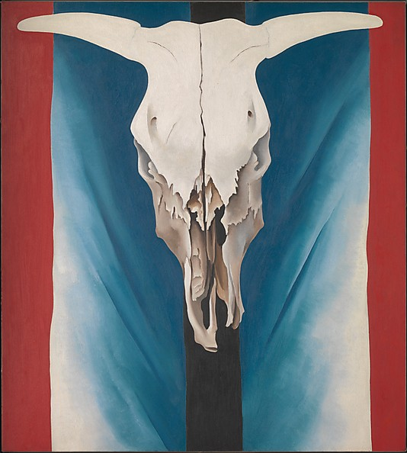

**Cow's Skull: Red, White, and Blue**, 1931

Georgia O'Keeffe (American, 1887–1986)

Oil on canvas; 39 7/8 x 35 7/8 in. (101.3 x 91.1 cm)

Alfred Stieglitz Collection, 1952 (52.203)

<http://www.metmuseum.org/collections/search-the-collections/488694>